Data Collection and Preprocessing Phase

Date | 23 June 2025
Team ID | SWTID1749709268
Project Title | Credit Card Approval Prediction
Maximum Marks | 6 Marks

Data Exploration and Preprocessing Template
Data has been sourced from Kaggle. Dataset variables will be statistically analyzed to identify patterns and outliers, with Python employed for preprocessing tasks like normalization and feature engineering. Data cleaning will address missing values and outliers, ensuring quality for subsequent analysis and modeling, and forming a strong foundation for insights and predictions.

Section | Description
Data Overview | application_record.csv  Dimension:  438557 rows x 13 columns  Descriptive Statistics:  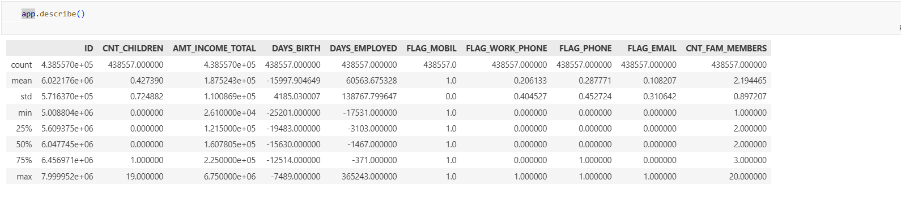  credit_record.csv  Descriptive Analysis:  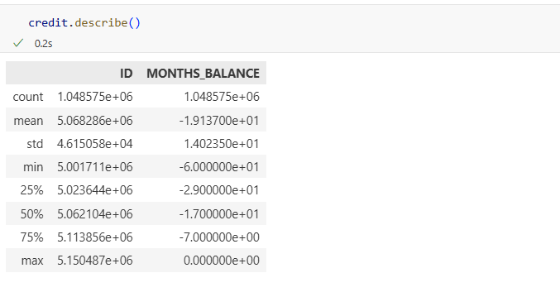
Univariate Analysis | 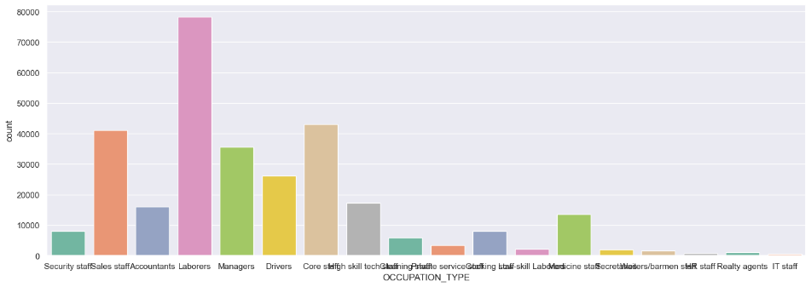  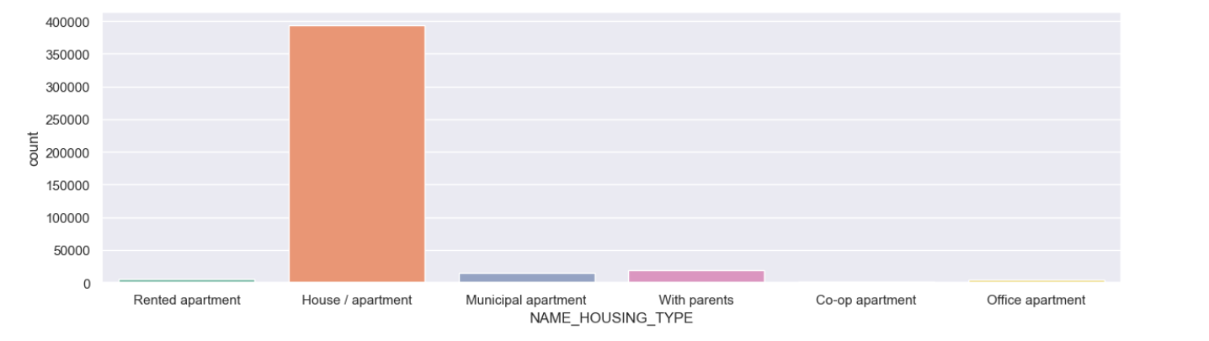  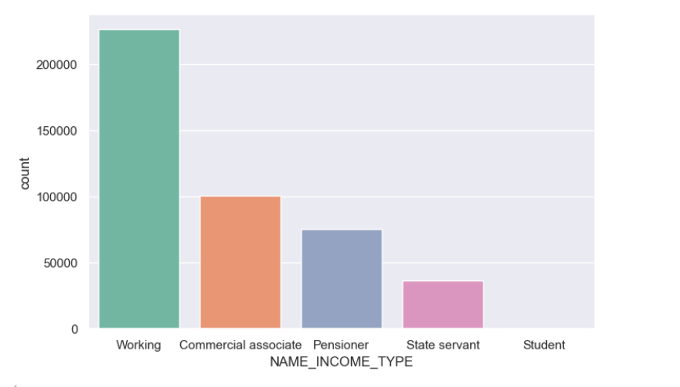
Bivariate Analysis | 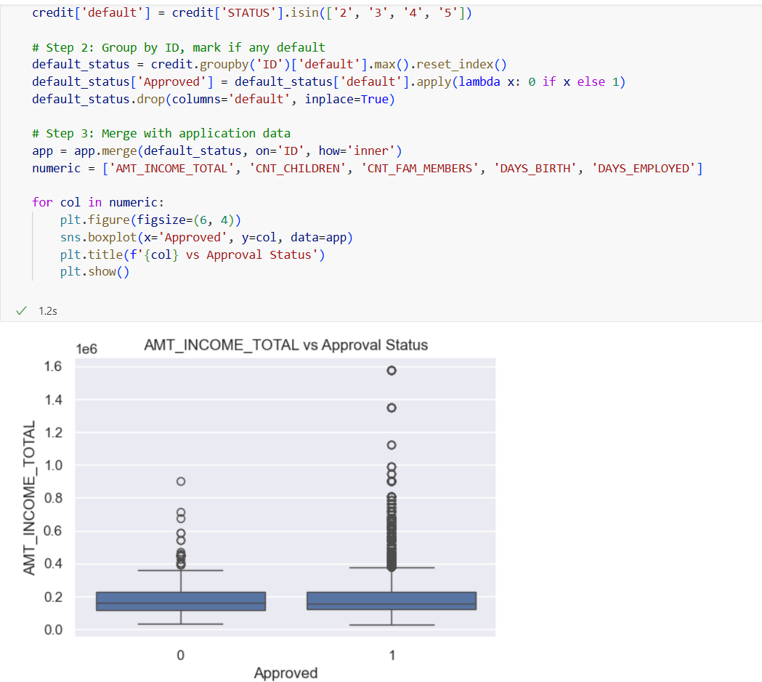
Multivariate Analysis | 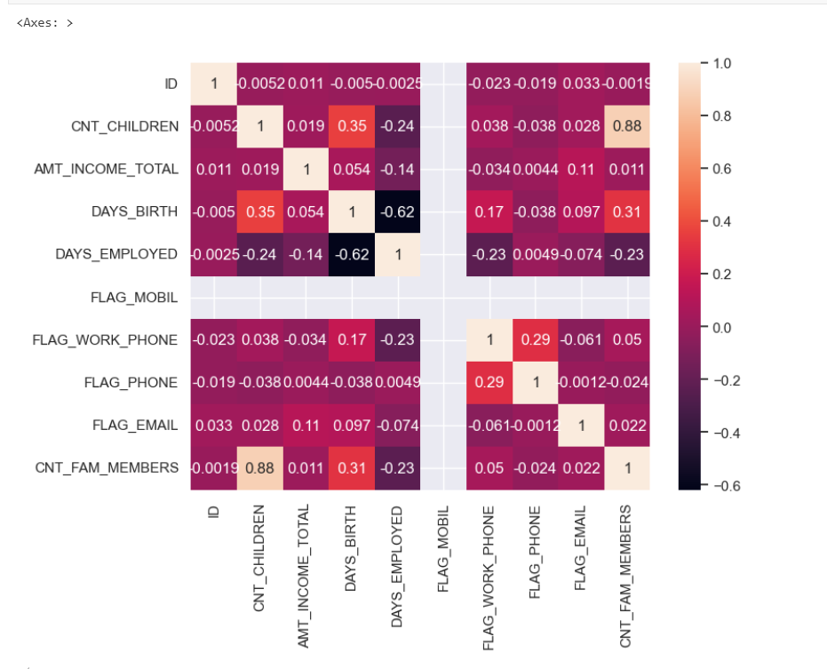
Outliers and Anomalies | Done using feature engineering and data cleaning stages as mentioned in notebook.
Data Preprocessing Code Screenshots
Loading Data | 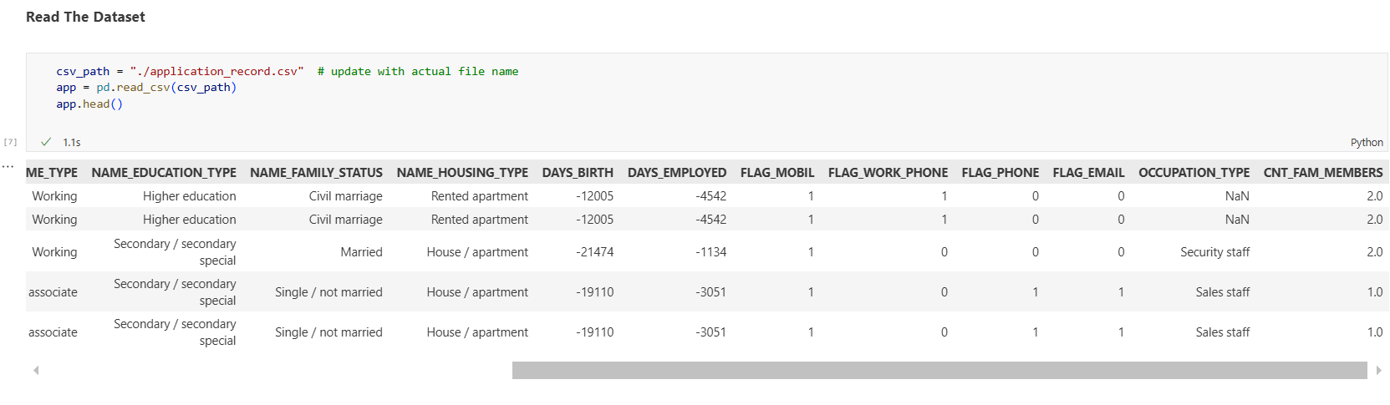
Handling Missing Data | 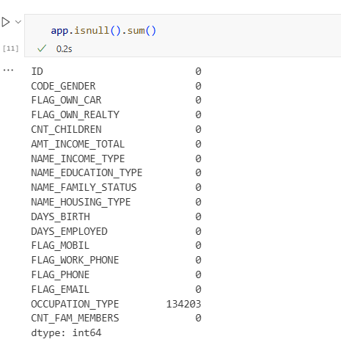
Data Transformation | 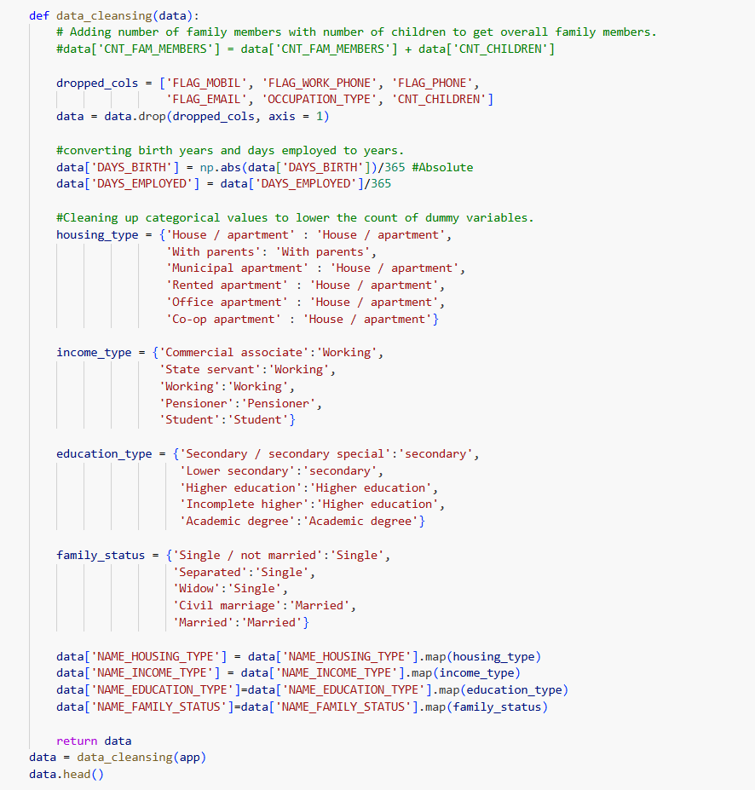
Feature Engineering | 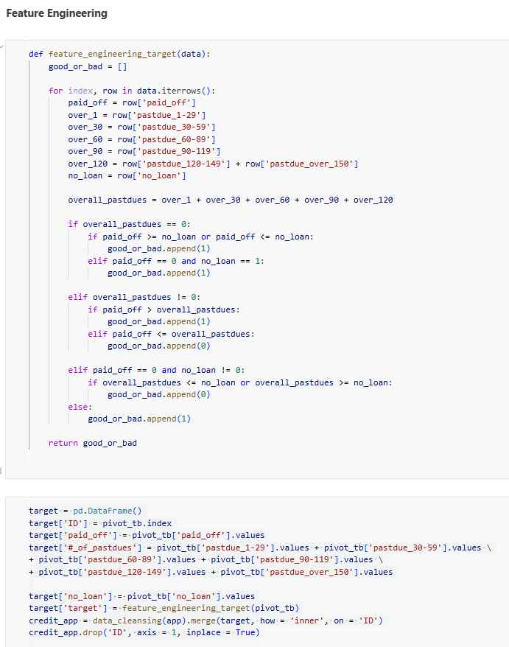
Save Processed Data | The processed data was saved dynamically in the app i.e. data frame for application_record.csv

